

# ML11-II

# Biological microscope

# User manual





**Guangzhou Micro-shot Technology Co., Ltd**

**[www.m-shot.com](http://www.m-shot.com)**

**Sales@m-sho.com**

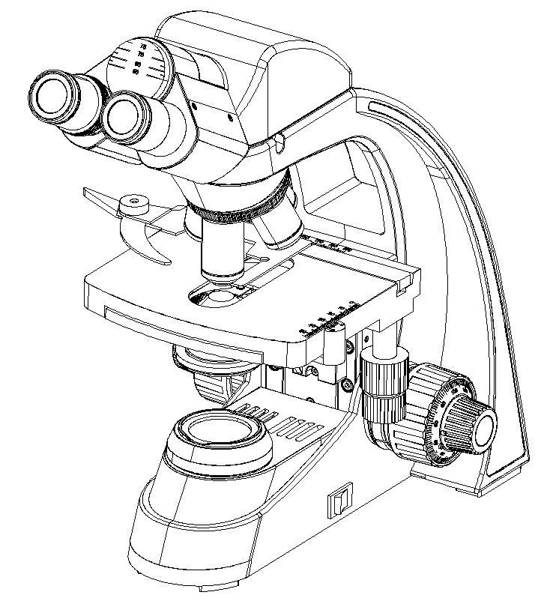

**Content**

**Ⅰ.Introduction.......................................................................................................................1**

**Ⅱ.Maintenance and service.............................................................................................1~2**

**Ⅲ. Safety signs.....................................................................................................................2**

**Ⅳ. Data sheet.......................................................................................................................2**

**Ⅴ. Microscope structure......................................................................................................3**

**Ⅵ. Installation.................................................................................................................4~6**

**1.Installation diagram.........................................................................................................................4**

**2.Installation steps..........................................................................................................................4~6**

**Ⅶ. Use of microscope....................................................................................................7~10**

**Ⅷ.Troubleshooting.................................................................................................10~11**

**Welcome to use ML11-Ⅱ biological microscope!**

**ML11-Ⅱ series biological microscope is widely used at biology and medical university laboratory, medical treatment and public health, scientific study instrument, etc.**

This unit is a precision optical instrument. Our product has been design to provide the highest level of safety, however, improper operation or negligence in following the instructions in this manual may cause personal injuries and property losses. In order to ensure your safety, prolong the life of this unit and maintain it properly, please read this manual carefully before operating this unit.

**Safety Reminder**

1. Be sure to turn off the power switch and remove the power cord before installing this unit, replacing the bulb or fuse, plugging and unplugging the power supply.



**!**

**Warning!**

To prevent electric shock or fire, be sure to turn off the power switch and remove the power cord before installing this unit, replacing the bulb or fuse, plugging and unplugging the power supply.

1. **Do not disassemble**



**!**

**Warning!**

Except the removable parts mentioned herein, no part of this unit shall be removed, otherwise the performance of this unit may be reduced, or may cause an electric shock, injury or damage to this unit. Please contact the supplier if any fault occurs.

1. **Input voltage**



**!**

**Warning!**

Check if the input voltage is consistent with your local voltage supply. If not, do not operate this unit and contact the supplier. Improper input voltage may cause a short circuit or fire thereby causes damage to this unit.

1. **Use specific bulb, fuse and power cord**



**!**

**Warning!**

Use of an improper bulb, fuse or power cord may cause damage or fire to this unit. Any extended power cord used must be grounded (PE).

**5. Protect this unit from high temperatures, dampness and foreign objects**



**!**

**Warning!**

To prevent short circuit or any other fault, do not expose this unit to any high temperatures or dampness environment for a prolonged period of time. A suitable operating environment is designated at a temperature of 5°C-35°C, and relative humidity of 20%-80% (at 25°C). If water splashes on this unit, turn off the power switch and remove the power cord immediately, and then wipe the water off with dry cloth. When any foreign object enters or drips onto this unit, please stop operating the unit and contact the supplier.

1. **Heat of light source**



**!**

**Warning!**

The lighting bulb generates high temperatures during operation. Do not touch the collector lens or lamp box when the lamp is illuminated, and do not touch the bulb within 10 minutes after the lamp goes out due to high temperatures arising from operation. When replacing the bulb, make sure it has cooled down properly (the lamp should be off for at least 10min).

* To prevent burn, do not touch the bulb when the lamp is illuminated or within 10min after it goes out.
* To prevent fire, do not place any fibrous product, paper, flammable or explosive material (e.g., gasoline, petroleum ether, alcohol) near the halogen lamp housing or mercury lamp housing.

1. **Coarse/fine focusing knobs**



**!**

**Warning!**

This unit employs a coarse/fine coaxial focusing mechanism. Do not turn the left/right coarse/fine focusing knob in the opposite direction. When the objectives lifting device reaches the limit of motion, do not continue to turn the coarse focusing knob, otherwise the focusing mechanism may be damaged.

1. **Storage place**

**Caution!**

This unit is a precision optical instrument, and improper operation or storage may cause damage or its precision may be adversely affected. Consider the following when selecting a storage place:

**※** Avoid placing the unit under direct sunlight, directly under interior lighting or any other bright place.

**※** A suitable operating environment is designated at a temperature of 5°C-35°C, and relative humidity of 20%-80% (at 25°C). Do not expose this unit to high temperatures, dampness or dust for a prolonged period of time, otherwise mist or mold may develop or dust may deposit on the lens, thus cause damage to this unit and shortening its life.

**9. Installation of bulb**

**Caution!**

Do not touch the glass surface of the bulb directly with bare hands. When mounting the bulb, wear gloves or wrap it with cotton material.

* Wipe off any dirt on the surface of the bulb with a clean cotton fabric dipped in alcohol. If the dirt is not thoroughly removed, it would etch the surface of the bulb weakening its brightness and shortening its life.
* Mount the bulb with care to avoid slipping off or injuries to your fingers.
* When replacing the bulb, make sure its contact is intact. If its contact is damaged, the bulb may be disabled or short-circuited.
* When replacing the bulb, the feet should be inserted into the holder as deeply as possible. If the feet are not tightly inserted, the bulb may go out or short circuit.

**10. Instrument handling**

**Caution!**

This precision optical instrument is heavy and should be handled with care. Strong impact and rough handling are strictly prohibited, it may cause damage to this unit.

1. **环保标识Environmental protection**

Please dispose the wastes from the packaging and operation of this unit by category such as cartoon, foam, plastic, bulb and etc. Do not discard the damaged mercury lamp carelessly in order to avoid creating environmental poll

**Ⅰ.Introduction**

Biological microscope ML11-Ⅱ is a basic optical microscope equipped with plan achromatic objectives and wide field eyepiece, featured with clear view, wide field and easy operation. It is quite popular for teachers and students to achieve interactive teaching on biology science. The biological microscope is widely used in the fields of biology, agriculture and it is an ideal instrument for education departments.

**Attention**

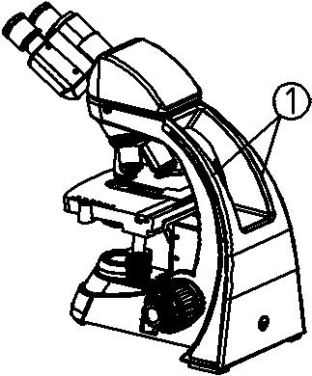1.Microscopes are precision instruments, which should be operated carefully to avoid physical vibration as much as possible.

2.Avoid placing the microscope in direct sunlight, high temperature or high humidity, dusty, etc And places prone to strong vibration, to ensure that the working surface is flat and level. Working environment requirements: room temperature 5 ℃～ 40 ℃, maximum relative humidity 80%.

3.When moving the microscope, hold the handle ① of the microscope arm with both hands, and be careful to place. (as Figure 01)

**★ if you grasp the stage, focusing knob and observation cylinder of the microscope when moving the microscope, it will damage the microscope.**

Figure 01

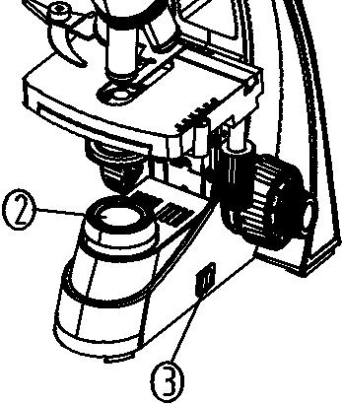

4. During operation, the surface of the light collecting will become very hot. Ensure that the area around the light collecting ② is enough for cooling space. (as Figure 02).

1. To ensure safety, make sure that the power switch is off before

replacing the bulb or fuse, at the same time wait until the bulb and lamp holder are completely cooled. (as Figure 02)

1. Standard configuration: 3W LED lamp of single bulb.



1. This machine does not put any disconnect devices in the difficult position.

Figure 02

**Ⅱ.Maintenance and service**

1.Clean the lens gently with gauze. If you want to remove fingerprints and oil stains, use a very small amount of ether (70%) to wipe off the mixture with alcohol (30%) or xylene.

**★ Both ether and alcohol are extremely flammable. Be careful not to close these chemicals to open fire and possible electricity. Use these chemicals in a well ventilated room as far as possible from the spark source, such as the opening and closing operation of electronic equipment.**



1. Do not use organic solvent to wipe the non optical parts of the microscope. For cleaning, use neutral detergent.
2. When using, if the microscope is wet by liquid, immediately cut off the power supply and dry it.
3. Do not disassemble the parts of the microscope. This may affect the function of the microscope or damage it.

5. When the microscope is not used, it shall be covered with a dust-proof cover.

|  |  |
| --- | --- |
| Identify | Meaning |
|  |  |
|  | Read the manual carefully before use. Improper operation may lead to Personal injury or instrument failure. |
|  |  |
| **|** | Power ON |
|  |  |
| **O** | Power OFF |
|  |  |

**Ⅲ. Safety signs**

**Ⅳ. Data sheet**

|  |  |
| --- | --- |
| Item | Specification |
| Eyepiece | WF10X/18mm |
| Observation head | 30°inclination,hinged trinocular observation head, interpupillary distance 50mm-75mm，single type diopter adjustable, fix light division R:T:80:20 |
| 30°inclination, hinged binocular observation head, interpupillary distance 50mm - 75mm, single type diopter adjustable **(optional)** |
| Objectives | Achromatic objective 4X/0.10, W.D.: 37.5mm |
| Achromatic objective 10X/0.25,W.D：6.55mm |
| Achromatic objective 40X/0.65,W.D：0.669mm |
| Achromatic objective 100X/1.25, W.D：0.198mm |
| Nosepiece | Quadruple nosepiece with inward tilt |
| Stage | 155mmx142mm double layer compound mechanical moving stage, moving range 76mmX50mm , accuracy 0.1mm |
| Focus | Low position hand wheel coaxial coarse and fine adjustment with limit stopper and lock device |
| Stage height movement (coarse movement stroke: 25mm) |
| Fine focusing accuracy 0.002mm |
| Transmitted illumination | 3W LED，Pre-set lamp center, brightness continues adjustable |
| Abbey condenser,N.A.1.25，with changeable aperture diaphragm |
| Filters: blue, yellow and green |
| Camera adapter | 0.5X C-mount |
| Power line | External set wide voltage power adapter, input 100V-240V-AC50/60HZ, outputDC12V2A |
|  | Immersion oil |
|  | Dust cover |

**Ⅴ. Microscope structure**

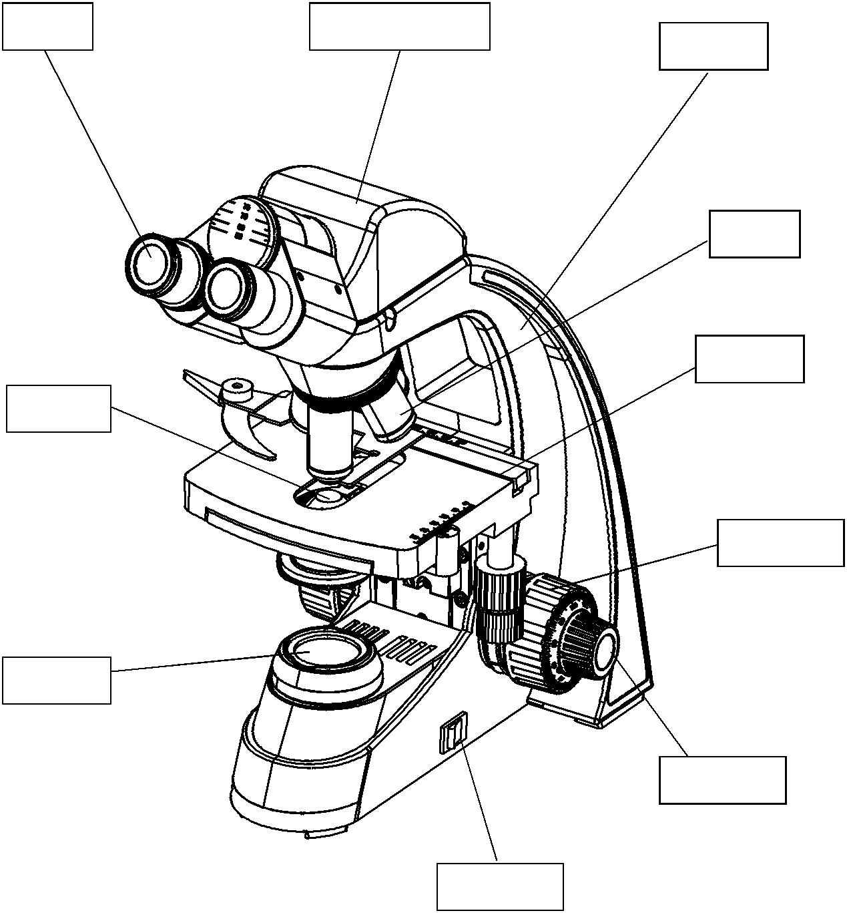

Binocular head

Eyepiece

Body

Objective

Stage

Condenser

Coarse knob

Light collecting

Fine knob

Power button

**Ⅵ. Installation**

**1.Installation diagram**

The following figure shows how to install various components. The number indicates the installation sequence.

★ before installation, make sure that all parts are free of dust, dirt and other foreign matters affecting assembly. When installing, be careful not to scratch, wipe any part or touch the glass surface.

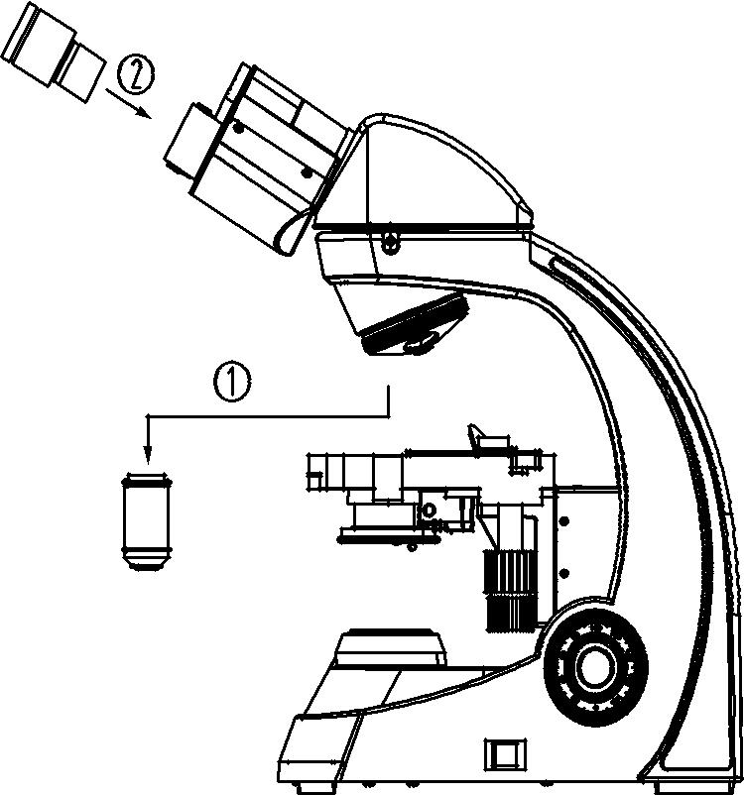

Eyepiece

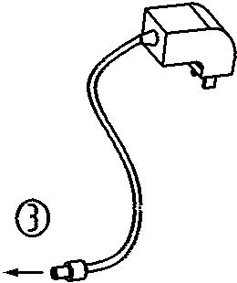

Objective

External power supply

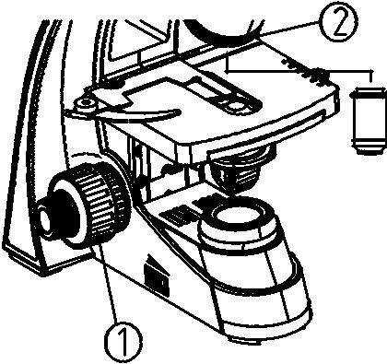

**2.Installation steps**

2.1**Installation objective**

1. Rotate the coarse hand wheel according to the direction of the chart, so that the loading platform can be lowered to a suitable position.

2. Then turn the objective nosepiece from low magnification to high magnification. Install it on the objective converter ②.

Figure 03

**★During operation, first search with low magnification objective lens (4x or 10x) . Look for the sample and focus it, then change the objective lens with high magnification as needed observation.**

**★ When replacing the objective, rotate the objective nosepiece until the ‘click sound is heard, so as to ensure that the required objective lens enters the light.**

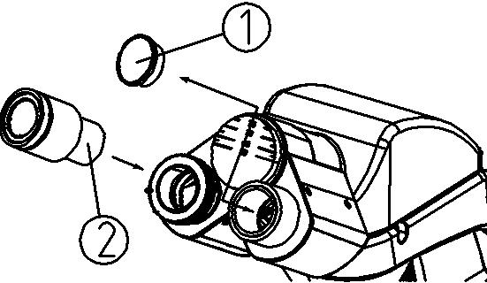

Figure 04

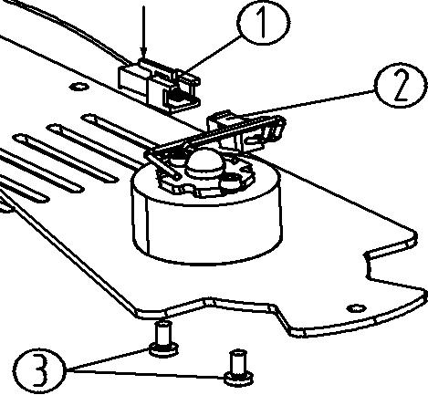

Figure 05

**2.2 Install eyepiece**

1. Remove the eyepiece tube cover ①.

2. Insert the eyepiece ② into the eyepiece tube until it is against the surface. (as shown in Figure 04)

**2.3 Install or exchange LED lamp**

Unscrew the fixing screws on the base plate group and take out the base plate group according to the figure 05.

Press and hold connector socket ① (connected with LED control panel) in the direction of arrow.

Pull out the connector plug ② (connected with the LED light) And then screw off the two screws ③ that fix the LED lamp group and replace them.

For the new LED lamp group, use the two screws ③ just removed to fix the LED lamp group, and insert the connector plug ② into the connector.

Plug in socket ①, and then assemble the base plate back to its original position. (as shown in Figure 5)

**★ Before replacing the LED lamp, first disconnect the main power supply of the microscope, and then replace it after the LED lamp group cools down to avoid LED The temperature of the lamp group is too high and burns.**

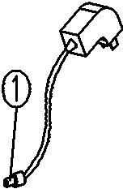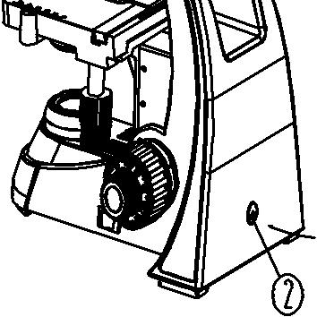

2.3 Connect external power adapter (power cord / charger)

★ Do not apply strong force to the power cord. When bending and winding, the power cord is easily damaged.

★ Always use the external power adapter (power Source line / charger), if it is lost or damaged, the external power adapter (power line / charger) with the same specification shall be selected.

Figure 06

**◎Applicable to the external power adapter of the host**



1. Before connecting the external power adapter, set the power switch to the "O" (off) state.
2. Insert one end of the external power adapter ① into the power socket ② of the microscope, and then install the other end
3. Fully plug into the power socket and ensure good contact. (as shown in Figure 6)

**★ DC12V 1A external power supply is adopted. Ensure that the external power adapter used meets this requirement.**

**★ if the model has a charging battery, the DC6V1A external battery charger must be used for charging. After the instrument is fully charged, the indicator light of the charger changes from orange to green. When replacing the charging battery, the high-quality 5# charging battery shall be selected.**

**Ⅶ. Use of microscope**

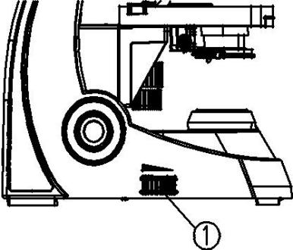**1.1 Illumination**

1. Turn on the power, and set the main power switch on the side of the microscope to "-" (on) status.

Figure 07

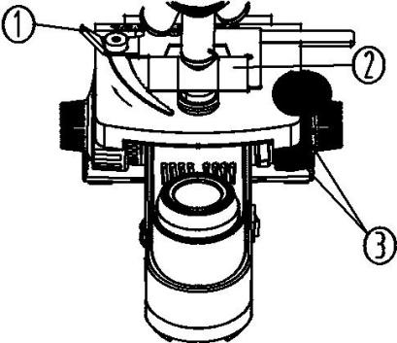

2. Adjust the dimming hand wheel ① to adjust the lighting brightness to a comfortable level.Turn the dimmer hand wheel clockwise to increase the voltage and make it bright (as Figure 07)

Figure 08

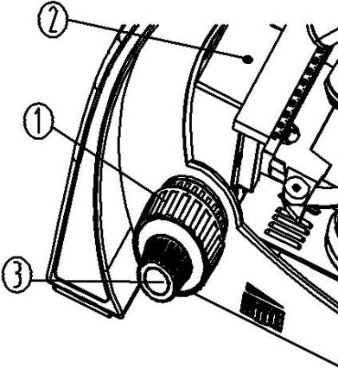

**1.2 Put slide**

1. Push back the wrench on the specimen holder.

1. Put the cover glass of slice ② upward into the slice holder, lightly open spanner ① easily and clamp the slice. (Figure 08)
2. Turn the vertical and horizontal hand wheels
3. ③ of the stage to move the specimen to the center position (aligned with the center of the objective lens).

Figure 09

**1.3 Focusing**

1. Move the 4x objective into the optical path.
2. Use the right eye to observe the right eyepiece, and turn the rough hand wheel ① until it is visible

The outline of the observed specimen appeared in the field. (Figure 09)

Figure 08

Figure 09

1. Turn the fretting hand wheel ③ to make the details of the specimen clear.

★ The limit screw ② can prevent the contact between the objective lens and the slice when focusing.

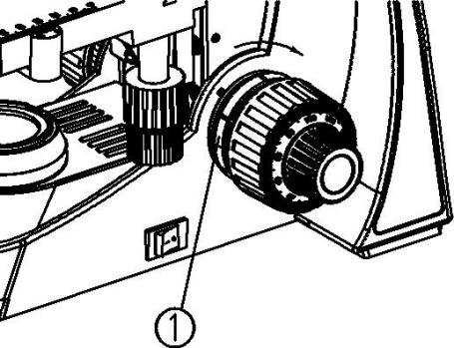**1.4 Adjustment of tightness of coke mechanism**

If the hand feel is heavy during coarse adjustment, uncomfortable or after focusing. And the product quickly leaves the focal plane, and the stage slides down by itself, which can adjust the hand wheel ① to solve the problem. (as shown in Figure 10)

Turn the adjusting hand wheel ① in the direction of arrow as shown in the figure to make the focusing machine When the mechanism is locked, turn the adjusting hand wheel ① in the opposite direction to

Figure 10 loosen the focusing mechanism.

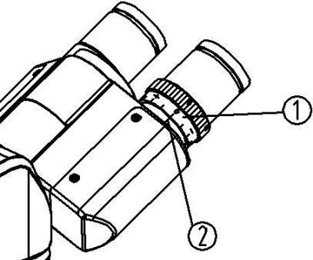

**1.5 Visual accommodation**

Observe the right eyepiece with the right eye, wait until the field of view is clear, and then observe the left eyepiece with the left eye. If it is not clear, rotate the visual adjustment Pitch ring ①, until the imaging is clear. (as shown in Figure 11)

**★ there are ± 5 diopters on the sight adjusting ring ① and the scale on the seat .The value corresponding to line 2 is the visual acuity value of the eye.**

Figure 11

* **When using the eyepiece with adjustable visibility, first set the visibility of the eyepiece to zero. During the use process, you can also adjust the visibility of the eyepiece to make the image clear.**

**★ remember your own visual acuity value so that you can use it next time.**

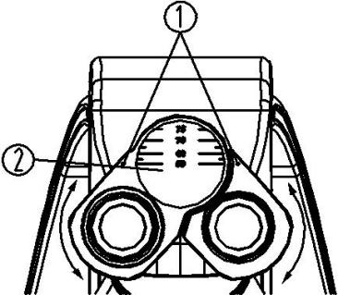

**1.6 Pupil distance adjustment**

When observing with both eyes, hold the left and right prism bases and rotate around the rotation axis. Adjust the pupil distance until the left and right visual fields are one and comfortable.

Figure 12

Indicator point "above eyepiece base." ① , pointing to the scale ② on the pupil distance indicator, indicating the size of pupil distance. (Figure 12) Pupil distance adjustment range: 50-75mm.

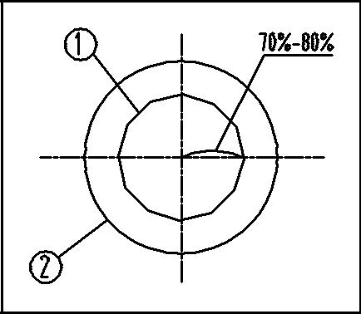**1.7 Use of condenser and aperture diaphragm**

1. Aperture diaphragm determines the numerical aperture of lighting system. Only illuminating system shows that the numerical aperture matches the numerical aperture of the objective lens.It can obtain better image resolution and contrast, and increase the depth of field 1.

1. Adjust the adjusting hand wheel ③ of the condenser clockwise to raise the condenser to the highest level so that the illuminating light can fill the whole field of view. Because the contrast of microsamples is usually low, the handle ④ should be turned to align with the condenser seat ⑤ when using. The magnification position corresponding to the multiple of the objective, even if the aperture of the condenser lens is adjusted to the value of the aperture of the objective 70%-80%. If necessary, remove the eyepiece, observe from the eyepiece cylinder, and adjust the handle ④ until it is as shown in Figure 13 to adjust the scale. (as shown in Figures 13 and 14, ① refers to aperture light bar image, ② refers to outer edge of objective.

Figure 13



**4.8 Use of oil immersed objective (100x)**

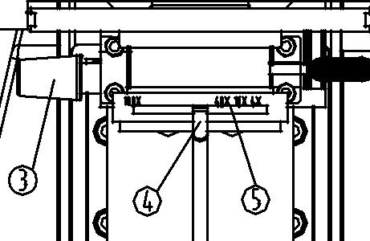

1. Focus the sample with 4x objective.

2.Drop a drop of immersion oil ① on the sample of the observation part. (as shown in Figure 15)

3. Turn the objective lens converter anticlockwise, turn the oil immersed objective (100x) into the optical path, and then use the inching handwheel to focus.

Figure 14

**★ Any bubble in the oil will have an impact on the image, and it should be confirmed that there is no bubble in the oil..**

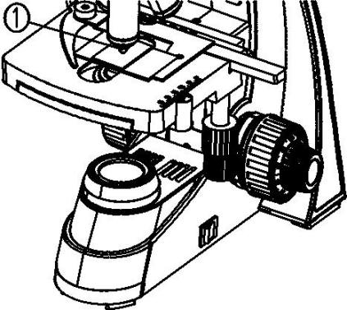

A.When checking bubbles, remove the eyepiece and open the field diaphragm completely and the aperture diaphragm, and then observe the outside of the objective through the eyepiece tube

edge (it looks round and bright).

B.To remove bubbles, turn the converter slightly and swing the oil immersion objective left and right several times.

Figure 15

4. After using the oil immersed objective lens, dip a small amount of 3:7 ethanol ether mixture with clean gauze or carefully wipe the front lens of the objective lens with xylene, and at the same time wipe off the immersion oil on the sample.

**★ when the immersion oil is not wiped off, do not turn other objective lenses into the optical path to avoid the immersion oil on the relevant objective lens.**

* **Too much xylene will dissolve the lens adhesive.**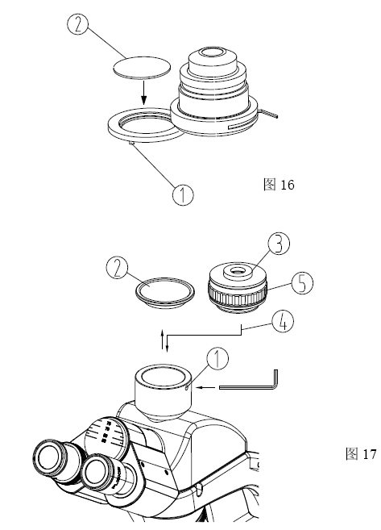

**1.9 Use filter**

Turn the filter shelf ① at the bottom of the condenser clockwise to filter. Press the color chip ② into its hole, and then screw it into the shelf anticlockwise. (as shown in Figure 16)

Figure 16

**★** **The filter is divided into three colors: blue, yellow and green.**

**1.10 Installation and use of camera**

1. Use the Allen wrench to loosen the locking screw ① on the three eye observation cylinder, take out the three-way dust cover ②. (as shown in Figure 17)

Figure 17

1. Screw CTV interface (C-type bayonet) ③ into CCD or camera.Then install the CTV equipped with CCD or camera into the three eye observation cylinder according to the direction ④ shown in the figure, and tighten the locking screw ①.
2. Conduct binocular observation. After the image is clear, observe the CCD image. If it is not clear, rotate the adjusting knob ⑤ to focus until the image is clear.e image is clear.

**Ⅷ.Troubleshooting**

If the performance of the microscope cannot be fully developed due to unskilled use, the following table can provide you with some solutions :

|  |  |  |
| --- | --- | --- |
| **Problem** | **Cause** | **Solution** |
| **1.Optical parts** | | |
| 1. Field is dark even light on | Aperture aperture is not large enough | Open aperture |
| Condenser too low | Adjust condenser height |
| 1. Field edge dark or uneven light and shade | Converter not in position | Go to the location of the converter |
|  | Lens (condenser, objective, eyepiece) ,there are dirty things on it. | Clean lens |
| 1. In the field of view has dirty things | There is dirt on the specimen | Clean sample |
| Dirt on each lens | Clean lens |
| 1. Image is not clear | No cover glass cover slide | Put on cover glass |
| Cover glass thickness is not accurate | Use δ0.17mm thickness cover glass |
| The specimen is in reverse | Correct |
| There is immersion oil on dry lens | Clean |
| There is not immersion oil on oil lens | Use immersion oil |
| There is bubble in immersion oil | Eliminate bubble |
| Use unmatched oil | Change to matched oil (Cedar oil) |
| Aperture diaphragm is too small or wide | Debugging to suitable size |
| There is dirt on the incident lens of the eye lens | Wipe off the lens |
| Condenser position is too low | Adjust |
| 1. Image one side is dark or image is moving when focusing | The specimen is floating | Fixed specimen |
| Converter not in position | Go to location |
| The condenser is not correctly aligned | Centering condenser |
| (6)Eyes are easy to fatigue, left and right vision field mismatch | Pupil distance incorrect | Adjust pupil distance |
| The eyepieces used in the left and right eyes are different | Use the same eyepiece |

|  |  |  |
| --- | --- | --- |
| **Problem** | **Cause** | **Solution** |
| **2.Mechanical part** | | |
| (1) Image with high power objective Inability to focus | The slides are reversed | Turn over slide |
| Cover glass is too thick | Use cover glass with standard thickness δ 0.17mm |
| (2) When the objective lens changes from low power to high power,it contacts with glass slide during conversion | The slides are reversed | Turn over slide |
| Cover glass is too thick | Use cover glass with standard thickness δ 0.17mm |
| (3) Rough handwheel is tight | The adjusting ring is too tight | Appropriate relaxation |
| (4) The stage descends by itself and does not stop on the focal plane during the observation. | The elastic adjusting ring is too loose | Appropriate lock |
| (5) Coarse adjustment handwheel cannot be raised | Stop screw locked | Loosen the limit screw |
| (6) Coarse adjustment handwheel cannot be lowered | The condenser base is too low | Raise the condenser base |
| (7) Specimen movement is not smooth | Specimen not in place | Repositioning |
| The mobile ruler is not fixed reliably | Really fasten |
| 1. When touching stage, image moved obviously | The stage is not fixed correctly | Fixed loading platform |
| **3.Electrical parts** | | |
| (1) The light is not on | No power | Check power line connection |
| Lamp is not correctly installed | Correctly install lamp |
| Lamp burned | Exchange lamp |
| 1. Lamp often burned | Has not used matched bulb | Exchange to standard bulb |
| (3)Brightness is not enough | Non specified bulb used | Use specified bulb |
| Incorrect adjustment of dimmer hand wheel | Correct adjustment |